**22AIE303 – PROJECT ABSTRACT**

**GROUP 5**

|  |  |
| --- | --- |
| **Name** | **Roll number** |
| Aparna Balaji | AM.EN.U4AIE22005 |
| Anuvind M P | AM.EN.U4AIE22010 |
| R S Harish Kumar | AM.EN.U4AIE22042 |
| Siddharth Menon | AM.EN.U4AIE22048 |

**ABSTRACT :**

ICTS department has the provision of five printers to print five different files at a time. The staff member can request for printing the required file. The files which have been printed, the details of the person who requested the print, date and time of print is to be maintained. Each print job is assigned to a clerical staff to verify if the printout request is valid, the staff who requested it is eligible, whether the request is official or personal, etc. based on which he/she takes the printout. One delivery person is responsible to deliver the printouts to respective staff member after checking the personal details such as name, room no of the staff member, phone no. The print details such as type of paper used (A3, A4, etc.), single page print or double side print, color print or not, etc. is also to be maintained. At a time, a file can be printed only on one printer. The cost of each print is to be maintained, to know the printing expense at the end of each month.

**ATTRIBUTES :**

1. ***Printer***: Printer_ID (Primary Key), Status (e.g., Available, Busy).
2. ***Staff***: Staff_ID (Primary Key), Name, Room_No, Phone_No.
3. ***Print_Request***: Request_ID (Primary Key), Date, Time, Purpose, Cost, Paper_Type (e.g., A4, A3), Print_Mode (Single/Double-sided), Color_Print (Yes/No).
4. ***Clerical_Staff***: Staff_ID (Primary Key), Name.
5. ***Delivery_Person***: Person_ID (Primary Key), Name, Phone_no.

***NOTE :***

*Staff.phone_no and Delivery_Person.phone_no are multivalued attributes.*

**ER-DIAGRAM :**

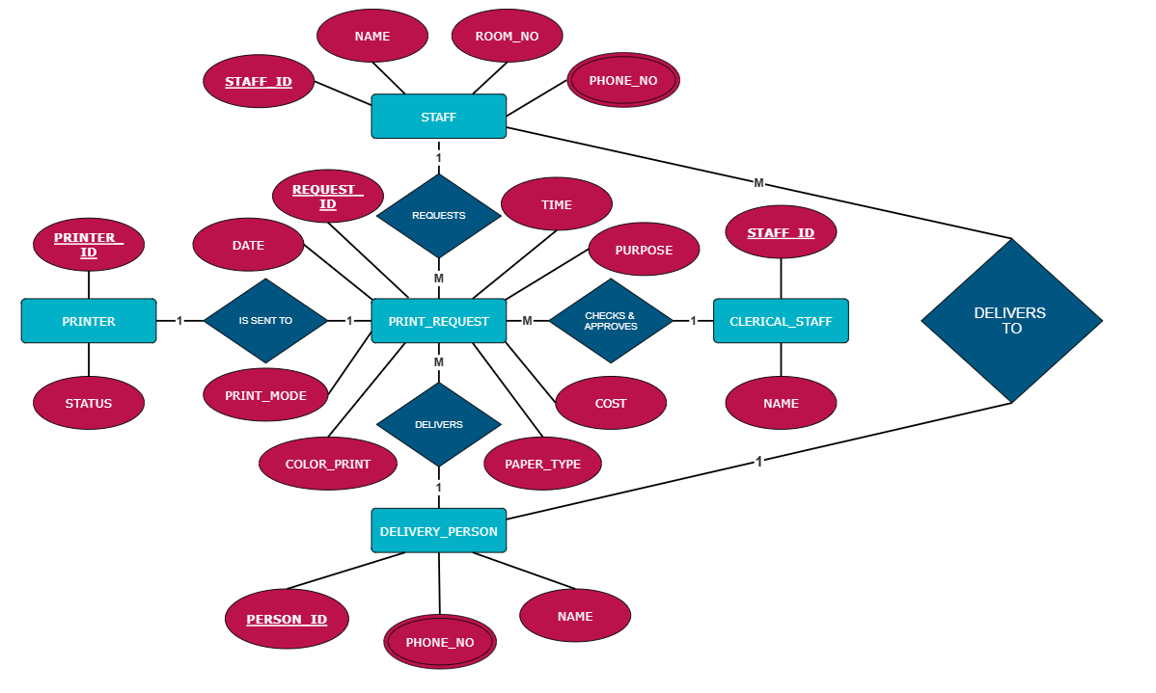

Note:

***Printer*** fully participates in the relation “is sent to” with ***print_request***